Agentes Secretos y el Mural de Picasso: Student Packet
Instrucciones: You will have to summarize every chapter in Spanish. 2s, you will start out summarizing in the present tense, but when we learn the past tense you will have to summarize in the past tense. 2+ will have to summarize in the past tense the whole time.

Capítulo 1:
- En español, escribe un resumen breve del capítulo. Incluye algunos detalles importantes al argumento.

- Dibuja una foto de cada personaje importante en el cuento. Incluye sus gustos, su apariencia, etc. (Paula, Luis, el papá de Luis, Francisco Franco)

Capítulo 2:
- Pre-reading listening activity: Go to https://www.youtube.com/watch?v=RlO8QytNO8A (direct link on my website) and answer the following questions in English.
- What is the main idea of this video? What information is this giving?

- Why is this specific lanza important? What makes it so special?

- Why did Hitler want the lanza del destino?

- Write down 3 other details you understood from this video and WHEN they were said.

- En español, escribe un resumen breve del capítulo. Incluye algunos detalles importantes al argumento.

- Dibuja una foto de los personajes en el capítulo (Javier y Mario)

Capítulo 3:
  - En español, escribe un resumen breve del capítulo. Incluye algunos detalles importantes al argumento.

  - Circle the parts of the mural that the chapter talks about (or highlight, color, something to make it stick out!)
El Mural de Picasso, “Guernica”
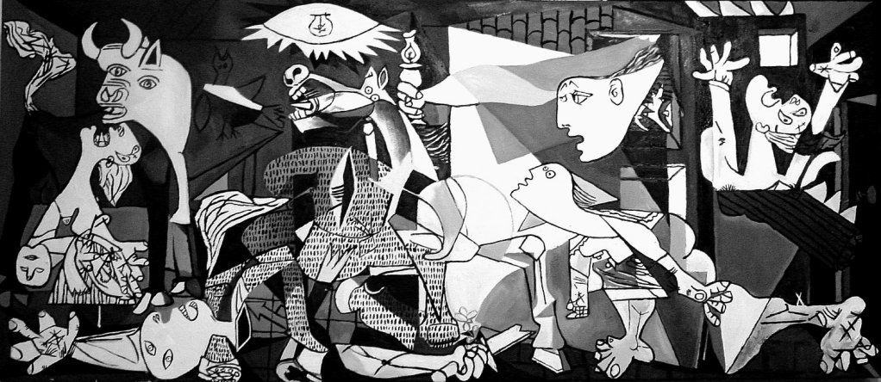

Capítulo 4:
    - Pre-reading Reading Activity:
Go to https://www.youtube.com/watch?v=io3K7TWIxas (direct link on my website) and answer the following questions.
- What is your impression of this church? React to it (in English!)

- What information are the windows telling? What story are they telling?

Go to http://www.sainte-chapelle.fr/es/ (direct link on my website) and answer the following questions in English (ALL of this info can be found on this website by looking through the tabs):
- What are the hours that it is open?

- What is the price of entrance for one person?

- Are dogs allowed?
    - En español, escribe un resumen breve del capítulo. Incluye algunos detalles importantes al argumento.

Capítulo 5:
      - En español, escribe un resumen breve del capítulo. Incluye algunos detalles importantes al argumento.

      - What happens when Luis wants to find information about the Lanza del destino?

  - Why is it important to know that Luis and Picasso are from Barcelona? How does it give them an advantage overe Mario and Javier?

Capítulo 6:
    - En español, escribe un resumen breve del capítulo. Incluye algunos detalles importantes al argumento

    - Why might someone call Mario creepy? (because he is is NOT a good response)

Capítulo 7:
      - En español, escribe un resumen breve del capítulo. Incluye algunos detalles importantes al argumento

      - Go to http://www.4gats.com/es/ (direct link on my website) and explore it. Answer the following questions
- Is this a casual, semi-casual, or nice restaurant? How do you know which one it is?

- When you make a reservation, what information is it looking for? Why is there a math question on there?

- What is the phone number? Does it look different than ours? Why do you think it is the way that it is?

- Go to the virtual tour http://www.4gats.com/es/tour-virtual/ (under the tab historia if you do not want to type this in) and explore around it. Write down your reaction and impression to the restaurant. Is this like something you would see here in Raleigh?

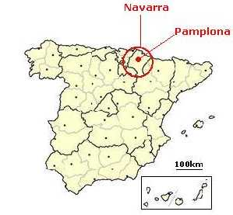
Capítulo 7:
To the left is a map showing the province of Navarra and the city Pamplona.
        - En español, escribe un resumen breve del capítulo. Incluye algunos detalles importantes al argumento

        - On the mural printed on earlier page circle the parts of the mural that this chapter talks about.

        - Why is the Lanza del Destino not in la Sainte-Chapelle?

Capítulo 8:
- What is the underlined sentence in the first page of the chapter saying?

- En español, escribe un resumen breve del capítulo. Incluye algunos detalles importantes al argumento

Capítulo 9:
- En español, escribe un resumen breve del capítulo. Incluye algunos detalles importantes al argumento

- Practica de leer: Go to http://www.amatimmobiliaris.com/w/plaza-felip-neri-testimonio-ciudad-asediada/ (direct link on my website) and look at the pictures and read it. You won’t understand all of it, but answer the following questions
  - What is this article telling us about? (main idea)

  - What does this article have to do with the chapter? How is it helpful to have these pictures and information in addition to the story?

  - En español, escribe una reacción breve al artículo. ¿Qué te hace pensar? ¿Qué te hace sentir? (Me hace pensar…. Me hace sentir…)

Capítulo 10:
- En español, escribe un resumen breve del capítulo. Incluye algunos detalles importantes al argumento

- Draw a picture of the scene that happens in this chapter. Add labels in Spanish to include details

Capítulo 11:
- En español, escribe un resumen breve del capítulo. Incluye algunos detalles importantes al argumento

- Draw a picture of the scene that happens in this chapter. Add labels in Spanish to include details

- Watch the first minute or so of this youtube video. Es un ejemplo de una corrida de los toros en Pamplona. https://www.youtube.com/watch?v=agDZMWH8oS8 (direct link on my website) In English, react to what you have just seen. What do you think about this? (4-5 sentences)

Capítulo 12:
- En español, escribe un resumen breve del capítulo. Incluye algunos detalles importantes al argumento

- Draw a picture of the scene that happens in this chapter. Add labels in Spanish to include details

Capítulo 13:
- En español, escribe un resumen breve del capítulo. Incluye algunos detalles importantes al argumento

- Draw a picture of the scene that happens in this chapter. Add labels in Spanish to include details

Capítulo 14:
- En español, escribe un resumen breve del capítulo. Incluye algunos detalles importantes al argumento

- Draw a picture of the scene that happens in this chapter. Add labels in Spanish to include details

- En español, escribe una reacción al cuento en general. ¿Te gusta? ¿Por qué sí o no? (5-6 frases)

