Homework for Technology Unit: Nombre: ____________ Periodo: ____
Interpretive Listening: http://tinyurl.com/hwtech1 Due Date: _____________
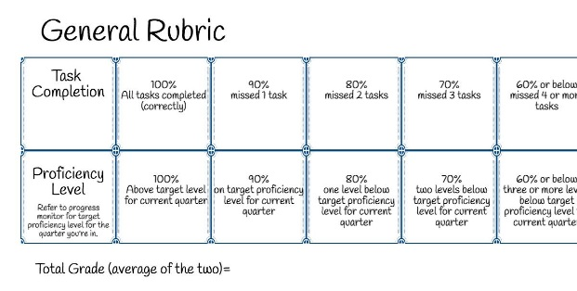
- Who is she talking about at the beginning? What does she say about this person?

- What does this person have to do with technology?

- What apps does she mention? Have you ever heard of them before?

- Why does she start talking about time? What does that have to do with technology?

Presentational Writing: Due Date: _____________
(No te metas a mi facebook reflection)

Interpersonal Speaking HW: Due Date: _______________
Name of partner: _______________ Number you called from: _______________ Date you called: __________
Call my google voice 980-785-4466 with anyone who is in my Spanish 2/2+ classes and have a conversation about technology using any of the prompts we’ve used in class. If you would like to be assigned a partner let me know! Some ideas are below for the prompts:
- A time that technology failed on you
- When a device broke
- When you got your first device
- Pretend you’re talking to someone who is going to fix your device
- A technological problem saga (a time that all the technology fails you!)
IN THE PAST TENSE!!!!

Interpretive Reading HW: Due Date: ______________
El Sueno de Robot Reading hw

