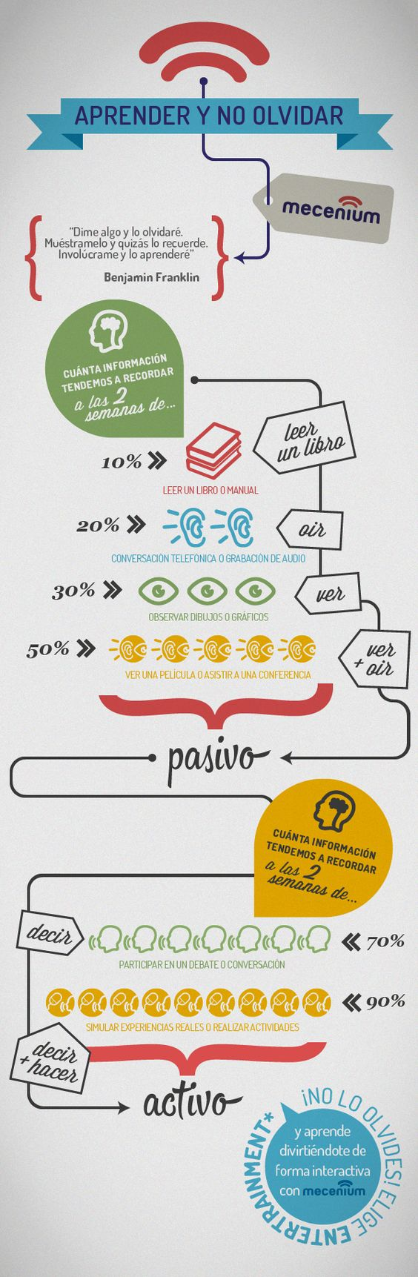\

Vocabulario Útil:

\*Olvidar: no recordar (olvidaré=voy a olvidar)

\*Tendemos: tenemos una tendencia

Reading Practice Activity: Glue this into the right side of your ISN, and answer the questions on the left side. This is a practice for your assessments, so take it seriously! The rubric as it will be on assessments will be projected on the board. If you want to know what you’d get on this practice assessment, come see me after/before school. and I’ll “grade” you.

1. What is this infographic about? Give as much details as possible and keep in mind the rubric (not for this activity, but this is a practice for what the assessments will look like) that this question will help me determine your proficiency level, which will be half of your grade.
2. What is the *activo* and *pasivo* referring to?
3. What information is this infographic giving? Why is it useful?
4. Who would be interested in reading this infographic? Who is the intended audience?
5. Write a reflection/reaction to this piece in English. What did you learn from it? What do you need to work on to apply this information? Write a full paragraph in English reacting to this infograph. Your grade will not be affected by what you say in this, but it is a “task” that you’ll need to complete to get your grade under the task completion on the rubric.



Vocabulario Útil:

\*Olvidar: no recordar (olvidaré=voy a olvidar)

\*Tendemos: tenemos una tendencia

Reading Practice Activity: Glue this into the right side of your ISN, and answer the questions on the left side. This is a practice for your assessments, so take it seriously! The rubric as it will be on assessments will be projected on the board. If you want to know what you’d get on this practice assessment, come see me after/before school. and I’ll “grade” you.

1. What is this infographic about? Give as much details as possible and keep in mind the rubric (not for this activity, but this is a practice for what the assessments will look like) that this question will help me determine your proficiency level, which will be half of your grade.
2. What is the *activo* and *pasivo* referring to?
3. What information is this infographic giving? Why is it useful?
4. Who would be interested in reading this infographic? Who is the intended audience?
5. Write a reflection/reaction to this piece in English. What did you learn from it? What do you need to work on to apply this information? Write a full paragraph in English reacting to this infograph. Your grade will not be affected by what you say in this, but it is a “task” that you’ll need to complete to get your grade under the task completion on the rubric.