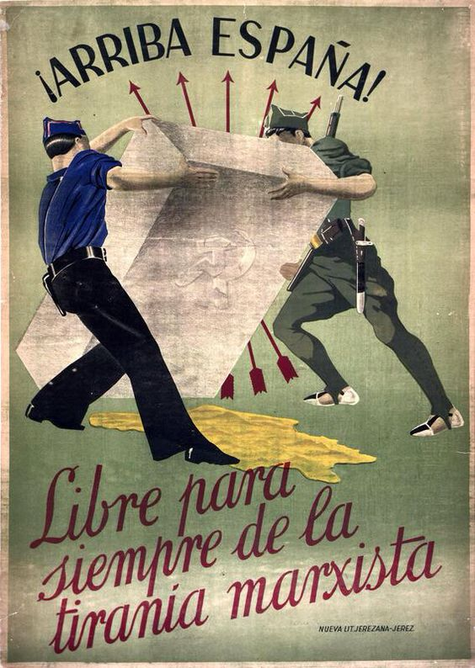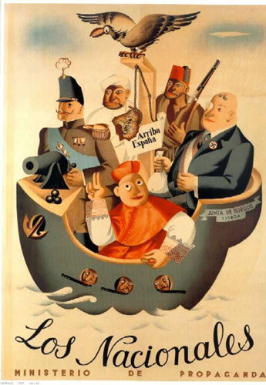

Pick one of the propaganda posters used in the Spanish Civil War. Tasks (EXACTLY like the major assessment)

* Knowledge of Spanish civil war is present in the picture (using specific knowledge and facts and not just something general about any war)
* Use of preteriré and imperfect
* Specify why you used pret and imperfect if it's iffy
* Creativity: Used prior knowledge and the picture to come up with something creative for the caption

Foto B

Foto A

Foto A

Foto A

Foto A