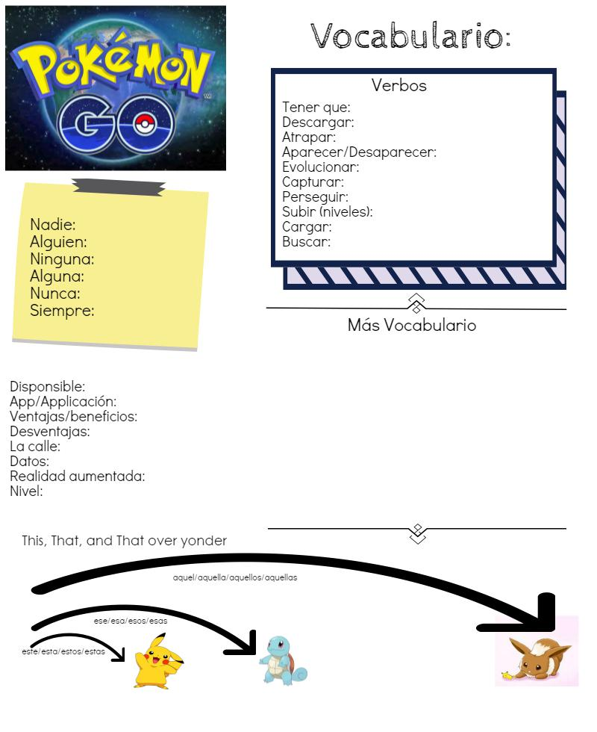

No one

Someone

None

Some

Never

Always

have to

download

trap/capture

appear, disappear

evolve

capture

pursue/chase/run after (add seguir: to follow/continue) conjugation e-i (sigo, sigues…)

to go up (levels)

to charge, to load

to search